Year 8 Life Skills Curriculum Plan
Game Review

Key Skills:

- To develop their ability to take turns within a structured play opportunity with peers
- To develop their ability to identify what they like and don’t like about a specific game or play opportunity
- To be able to participate in a team work task when creating their video game review.

This term pupils will be given structured opportunities to play a variety of games with their peers as well as working as part of a team to create a game review video. During these sessions’ pupils will be supported to develop their turn taking, team work and problem-solving abilities. Pupils will participate in small group discussions, role play activities and be given opportunities to share what features they like and do not like in a game. This term pupils will take on a specific role such as director, interviewer, reviewer or camera person and work as part of a team to create a game review video.

Key vocabulary:
Review, respect, like, do not like, positive, negative, director, reviewer, camera person, interviewer, compliment, feedback

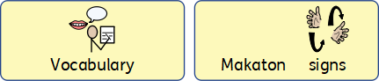

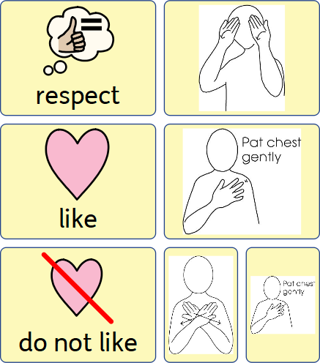
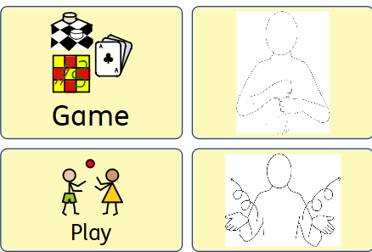

Topics and Opinions
Aims:

- To be able to demonstrate respect to others in a small group discussion.
- To develop their ability to share their ideas in a small group.
- To develop their social thinking abilities and understanding that others can have different opinions.
- To develop their ability to answer why questions and provide rationale for their thoughts and opinions.

This term the pupils will be supported to develop their ability to share their ideas on specific topics such as social media, food choices, animals as pets and many more. In small group settings pupils will be given the opportunity to plan their ideas using a shape coding planning template. They will then be given the opportunity to share their ideas and practice listening to others. Pupils will be encouraged to expand on their utterances and answer higher level language questions such as why. This topic will provide pupils to have an opportunity to develop their social thinking skills.

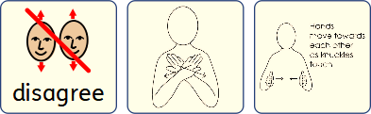
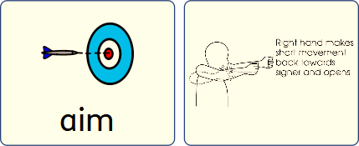
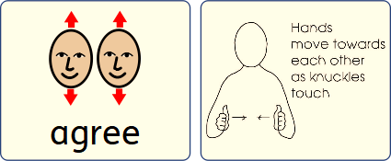
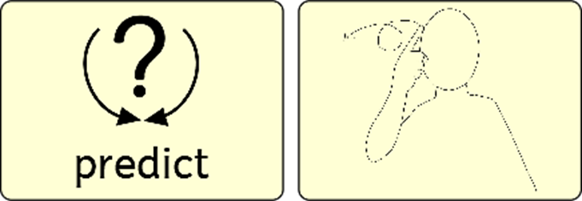

Occupational Therapy – Autumn Term
Preparation for Life
Occupational therapists and Speech and Language therapists at Blossom House School deliver combined Preparation for Life days to pupils for one full day each half term. These days aim to develop social, motor and process skills alongside overall independence. The domains of focus this term are Food preparation and Independent travel.
The following skills will be covered under the Food Preparation topic:
- Following recipes
- Chopping, slicing and grating
- Using ovens and hobs
- Kitchen safety
- Kitchen hygiene
The following skills will be covered under the Independent Travel topic:
- Planning journeys
- Appropriate behaviour on transport
- Road safety
The sessions aim to support students to break down tasks into process, motor and communication skills and encourage them to develop their self-reflection and adaptation skills. This will help the students to gain self-awareness and confidence in their own abilities. Teaching and support staff will be informed of specific skills that can be further developed throughout the school term. Where possible, parents will also be encouraged to continue this work at home, promoting independence in day to day tasks.

