Year 7 Life Skills Curriculum Plan
Attention strategies

Aims:
- To develop pupils’ attention and listening skills
- To identify how the environment around us can cause distractions.
- To reflect on attention strategies that help them- e.g. mindfulness, drinking water.
- To be able to sustain attention to an adult-led task for increasing lengths of time.
- To be able to share an idea about a group activity.
- To develop attention skills.
- To respect peers’ views when sharing opinions.
- To build understanding of social situations.

Pupils will develop their ability to identify strategies to aid their attention when distracted. They will use creative activities, team discussions and challenges to learn about and use learnt strategies. They will explore and identify what affects their own attention and the strategies that can be used to regain focus. They will reflect on different strategies during group discussions.

Key vocabulary: focus, attention, respect, discuss, listen, distraction, strategy, skills, emotions

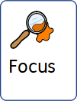 | 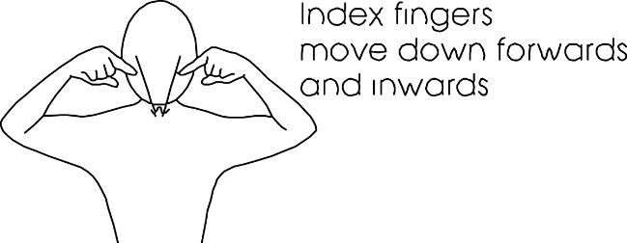
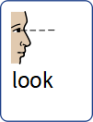
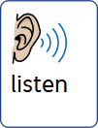
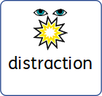 | 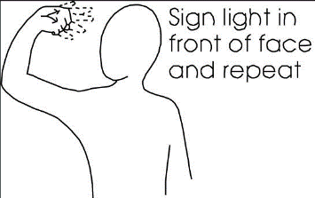
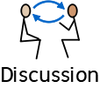 | 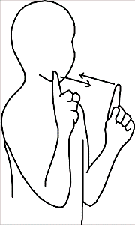
Group rapport and wellbeing

Aims:
- To be able to develop pupils’ emotional literacy skills.
- To develop the pupil’s awareness of a range of emotional regulation strategies.
- To enable the pupils to participate in a shared positive experience.
- To participate in a range of mindfulness strategies.
This term pupils will be provided with an opportunity to participate in a range of shared experiences such as multisensory challenges, team games and rapport-building activities. Pupils will share their ideas through a range of mediums such as spoken word, role play, art as well as images. Wellbeing strategies will be explored and pupils will have the opportunity to practice mindfulness strategies such as belly breathing, meditation, calm music and mindful narratives.
Key vocabulary:
Emotions/feelings, wellbeing, mindfulness, calm, strategies, help,
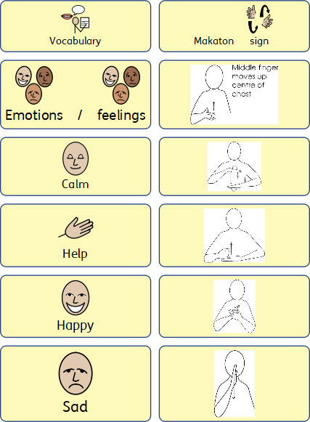

Daily Living Skills Autumn Curriculum Plan

This session is run jointly by an Occupational Therapist and Speech and Language Therapist. These collaborative sessions aim to develop self-awareness, improve confidence and overall independence in various day to day tasks. The main core skill areas for year 7 include personal hygiene and body awareness; home organisation and activities of daily living; and road safety and community access. Within these core areas; the following topics and skills will be covered during the Autumn term: Personal hygiene and Body awareness.
Aims: To explore the importance of and become more independent in…

- Handwashing hygiene
- Morning routine and self-care including brushing teeth, washing hair, using deodorant, showering, sleep hygiene and knowing when to change and wash clothes.
- Exploring body awareness, staying clean and dealing with body odour.

Where possible, parents will also be encouraged to continue this work at home, promoting independence in day to day tasks and your child’s self-care routine.

Year 7 Therapies Carousel
This lesson is an extra lesson for our Year 7 students which provides these students with extra wellbeing input from our therapy team. Each half term is a different topic and is led by Speech and Language Therapists, Occupational Therapists or Arts Therapists.

This term Year 7 are receiving a half term of Arts Therapy group based on the theme of transition. These groups are led by a member of the in-house Arts Therapy team, and supported by the group’s attached Speech and Language Therapist and explore feelings around change, transition and the newness of secondary school within the safe environment of the group.

Next half term Speech and Language Therapists will be delivering a 6-week block of Social Thinking therapy where students are taught about different characters in the Unthinkables programme (by Stephanie Madrigal and Michelle Garcia Winner). These characters help talk about areas of need our students may find hard including flexibility; perspective taking; social awareness and self-regulation. These characters can then be used throughout their school day to help them recognise and use strategies to work through trickier moments.

